GNU Octave, version 3.8.2
Copyright (C) 2014 John W. Eaton and others.
This is free software; see the source code for copying conditions.
There is ABSOLUTELY NO WARRANTY; not even for MERCHANTABILITY or
FITNESS FOR A PARTICULAR PURPOSE. For details, type 'warranty'.

Octave was configured for "x86_64-pc-linux-gnu".

Additional information about Octave is available at http://www.octave.org.

Please contribute if you find this software useful.
For more information, visit http://www.octave.org/get-involved.html

Read http://www.octave.org/bugs.html to learn how to submit bug reports.
For information about changes from previous versions, type 'news'.

a = 1.000000
l = 1.000000
T = 0.200000

ε = 0.000000

n = 10
k = 10
hx = 0.100000
ht = 0.020000

Начальное возмущение =
0.25 * sin(pi * x)

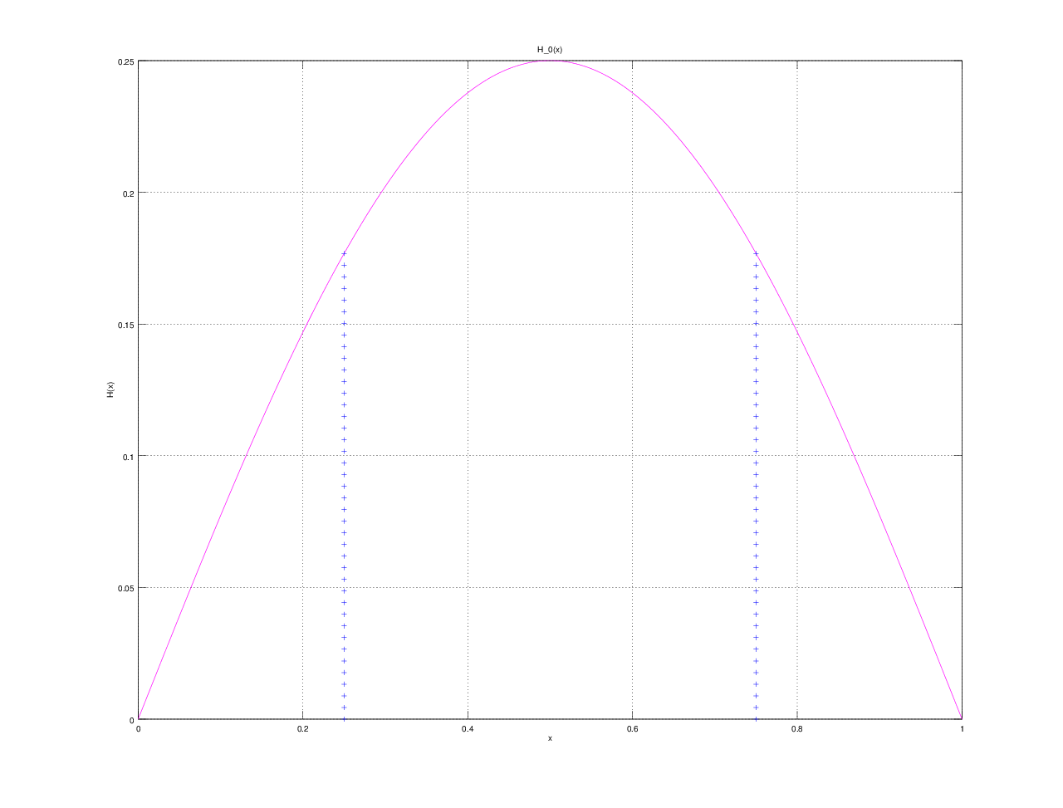

Всего демпферов: 2

Демпфер # 1

x_1 = 0.250000

Верхнее предельное значение w_1(t) =
15

Нижнее предельное значение w_1(t) =
NaN

Управляющая функция w_1(t):
0.84106
-3.92792
-4.98158
-6.27545
2.31638
6.37851
14.99993
13.20275
13.61102
2.20078
2.88786

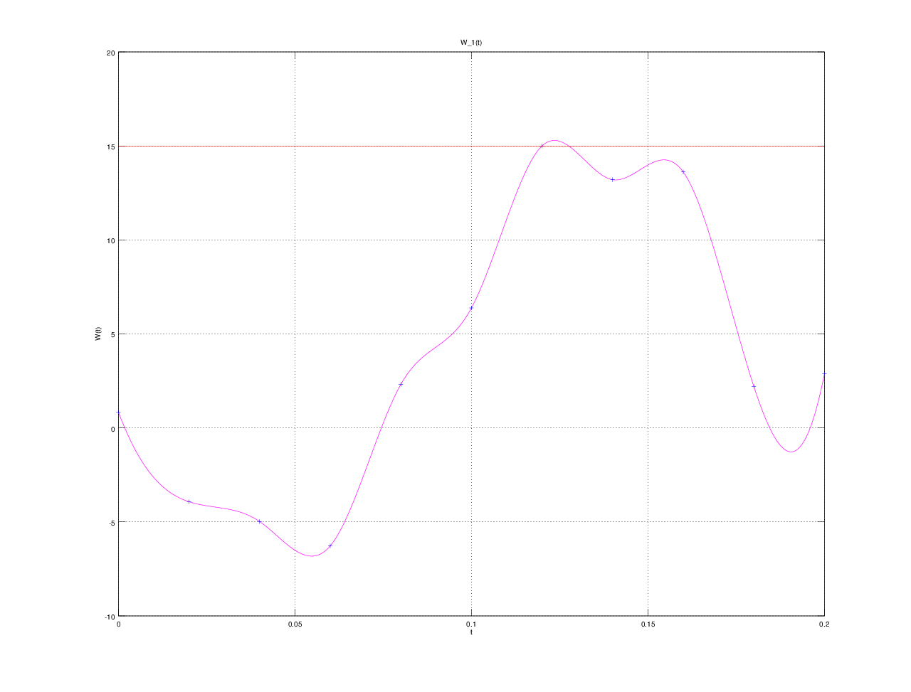

Демпфер # 2

x_2 = 0.750000

Верхнее предельное значение w_2(t) =
15

Нижнее предельное значение w_2(t) =
NaN

Управляющая функция w_2(t):
0.81913
-3.91998
-4.99509
-6.24924
2.30493
6.37136
14.99470
13.21651
13.61178
2.19775
2.88866

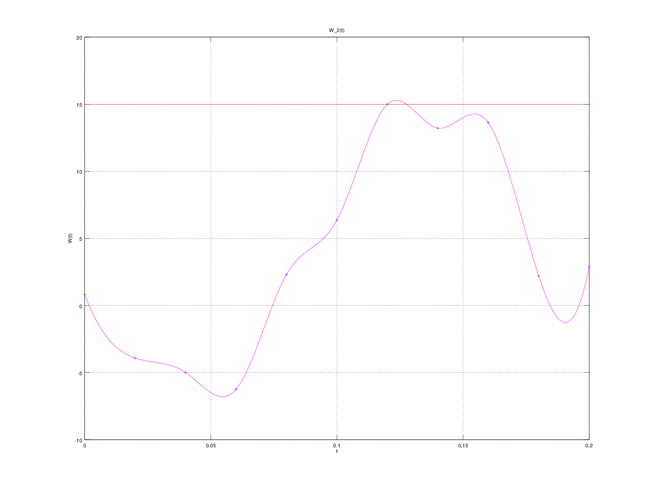

E(T) =
5.6508e-10

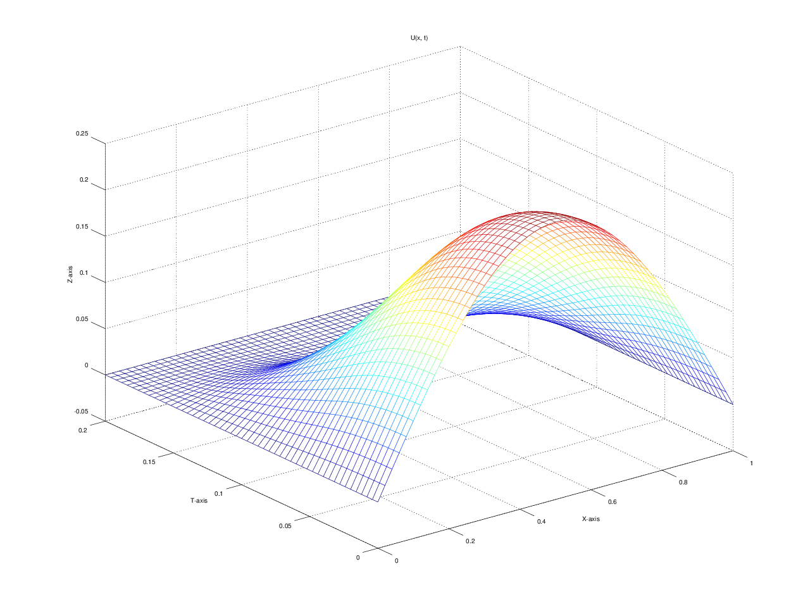

u(x, t)
T = 0.000000: 0.000000 0.077254 0.146946 0.202254 0.237764 0.250000 0.237764 0.202254 0.146946 0.077254 0.000000
T = 0.020000: 0.000000 0.075299 0.143186 0.197462 0.232740 0.244942 0.232738 0.197457 0.143181 0.075297 0.000000
T = 0.040000: 0.000000 0.068693 0.131014 0.182070 0.216357 0.228408 0.216349 0.182058 0.131001 0.068685 0.000000
T = 0.060000: 0.000000 0.057551 0.110728 0.155515 0.186347 0.197347 0.186339 0.155503 0.110716 0.057543 0.000000
T = 0.080000: 0.000000 0.044977 0.086624 0.120845 0.143468 0.151412 0.143470 0.120848 0.086627 0.044979 0.000000
T = 0.100000: 0.000000 0.033688 0.063042 0.083615 0.094507 0.097879 0.094518 0.083630 0.063057 0.033699 0.000000
T = 0.120000: 0.000000 0.023021 0.041088 0.049619 0.050420 0.049890 0.050427 0.049630 0.041099 0.023027 0.000000
T = 0.140000: 0.000000 0.012437 0.021582 0.023429 0.019990 0.018019 0.019989 0.023428 0.021581 0.012436 0.000000
T = 0.160000: 0.000000 0.004383 0.007743 0.007582 0.004817 0.003458 0.004814 0.007577 0.007738 0.004380 0.000000
T = 0.180000: 0.000000 0.000721 0.001364 0.001119 0.000183 -0.000242 0.000182 0.001117 0.001361 0.000720 0.000000
T = 0.200000: 0.000000 0.000000 0.000002 -0.000000 -0.000003 0.000001 -0.000003 -0.000000 0.000002 0.000000 0.000000

